- Purpose
  - The purpose of this document is to describe the procedure for assembling the eccentric on an orbital machine.
- Scope
  - This SOP applies to all equipment assembly team members. The process applies to the following machine ID’s:
E012801EQM0600BA1000 – Basic Sand Dragon, 20”
E012801EQM0607BE1200 – Crewman ORB 20
E012801EQM0607BA1200 – Basic Sand Dragon 20, Canadian
E012801EQM0607BE1200 – Crewman ORB 20, Canadian
E012806EQM0600BA1000 – Basic Sand Dragon, 20”, w/ Weights
E012806EQM0600BE1200 – Crewman ORB 20, w/Weights
E012806EQM0607BA1200 – Basic Sand Dragon 20, w/Weights, Canadian
E012806EQM0600BE1200 – Crewman ORB 20, w/Weights, Canadian
E012811EQM0600BA1000 – Basic Sand Dragon, 28”, w/Weights
E012811EQM0600BE1000 – Crewman 28 ORB, w/Weights
E012811EQM0607BA1200 – Basic Sand Dragon 28, w/Weights, Canadian
E012811EQM0607BE1200 – Crewman ORB 28, w/Weights Canadian
- Responsbilities
  - The operations manager/supervisor is responsible for enforcing this SOP.
- Materials
  - The proper materials needed for this process are listed on the machine work order.
  - Hammer
- Definitions

- Procedure
  - Take an eccentric (89654) and install a roll pin (89915) into the hole shown. This can be installed using a hammer. Verify that the top of the roll pin is installed past the surface of the eccentric so the bearing will fit.

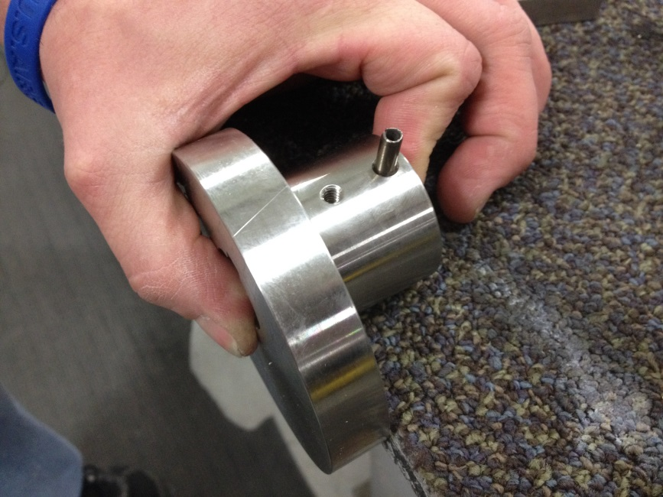

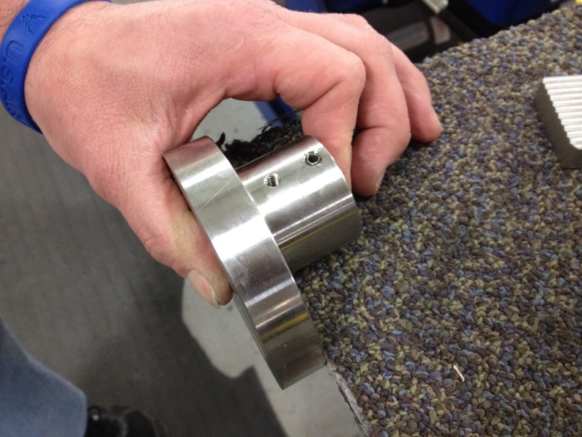

- References (optional section as needed)

- Training Guide

Functional Training Groups Requiring Training
Equipment Assembly Group

- SOP Change Control

Date of Change | Reason for Change
4/28/2015 | This is the first version of the S.O.P. hence there are no revisions to this document.
1/16/2018 | Added the Responsibilities Section
10/15/2024 | Updated Machine ID’s

Approvals

Submitter/Author Approval:__________________________________ Date:______________________

Management Approval:______________________________________ Date:______________________

QAU Approval:_____________________________________________ Date:______________________

